# Tugas Pemrograman Berorientasi Objek



**Muhamad Salman Adhim Baqy**

**A11.2020.12641**

**Fakultas Ilmu Komputer**

**Program Studi Teknik Informatika**

**Universitas Dian Nuswantoro**

**2022**

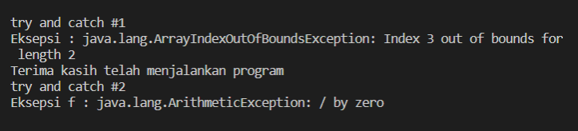1.Contoh Eksepsi

|  |
| --- |
| package Eksepsi;  import java.io.File;  import java.io.FileReader;  public class contohEksepsi {      public static void main(String[] args) {          System.out.println("\n");          // checked          File file = new File("E://file.txt");          // FileReader fr = new FileReader(file);          // unchecked          int num[] = { 1, 2, 3, 4 };          // System.out.println(num[5]);          // try & catch          System.out.println("try and catch #1");          try {              int a[] = new int[2];              System.out.println("Akses elemen ke-3 : " + a[3]);          } catch (ArrayIndexOutOfBoundsException e) {              System.out.println("Eksepsi : " + e);          } finally {              System.out.println("Terima kasih telah menjalankan program");          }          System.out.println("try and catch #2");          try {              int b = 1 / 0;              System.out.println(b);          } catch (NullPointerException e) {              System.out.println("Eksepsi e : " + e);          } catch (ArithmeticException f) {              System.out.println("Eksepsi f : " + f);          } catch (ArrayIndexOutOfBoundsException g) {              System.out.println("Eksepsi g : " + g);          } catch (Exception h) {              System.out.println("Eksepsi h " + h);          }          //          System.out.println("\n");      }  } |

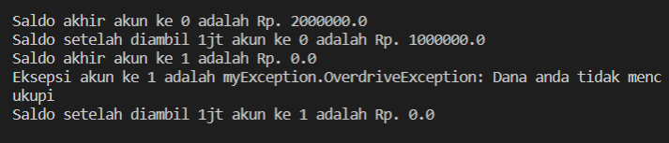2. Membuat Eksepsi Sendiri

OverrideException.java

|  |
| --- |
| package myException;  public class OverdriveException extends Exception {      // eksepsi sendiri      private double deficit = 0;      public OverdriveException(String msg, double deficit) {          super(msg);          this.deficit = deficit;      }      public double getDeficit() {          return deficit;      }  } |

Account.java

|  |
| --- |
| package myException;  public class Account {      protected double balance;      protected Account(double initBalance) {          balance = initBalance;      }      public double getBalance() {          return balance;      }      public void deposit(double amt) {          balance += amt;      }      public void withdraw(double amt) throws OverdriveException {          if (amt <= balance) {              balance -= amt;          } else {              throw new OverdriveException("Dana anda tidak mencukupi", amt - balance);          }      }      public static void main(String[] args) {          System.out.println("\n");          int i;          Account[] acc = new Account[100];          acc[0] = new Account(2000000);          acc[1] = new Account(0);          for (i = 0; i < 2; i++) {              double d = acc[i].getBalance();              System.out.println("Saldo akhir akun ke " + i + " adalah Rp. " + d);              try {                  acc[i].withdraw(1000000);              } catch (OverdriveException e) {                  System.out.println("Eksepsi akun ke " + i + " adalah " + e);              } finally {                  double b = acc[i].getBalance();                  System.out.println("Saldo setelah diambil 1jt akun ke " + i + " adalah Rp. " + b);              }          }          System.out.println("\n");      }  } |